Crunchy Corner Restaurant Data: EDA and Data Cleaning

-- Exploratory Data Analysis And Data Cleaning and Checking

SELECT * FROM Fact_Table

SELECT * FROM Buget

SELECT * FROM Cluster

SELECT * FROM Location

SELECT * FROM Date_Table

SELECT * FROM Products

-- Data Quality Check of Products Table
--(1) Checking Product Id is Unique and Not duplicated
SELECT
Product_id ,
COUNT(*)
FROM Products
GROUP BY
Product_id
Having COUNT(*)>1;

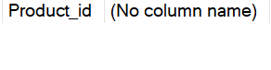

-- (2) Checking Duplicates for SKUs
SELECT
SKU_Code ,
COUNT(*)
FROM Products
GROUP BY
SKU_Code
Having COUNT(*)>1

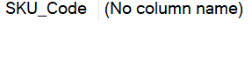

(3) Null & Missing Value Check
SELECT * FROM Products
WHERE
Product_id IS NULL
OR
SKU_Code IS NULL
OR
SKU_Description IS NULL
OR
Category IS NULL
OR
Sub_Category IS NULL

--(3) Data Consistency Checks
-- Checks for Misclassified Products

SELECT
Product,
COUNT(DISTINCT Category) as Category_Count
FROM Products
GROUP BY Product
HAVING COUNT(DISTINCT Category)>1

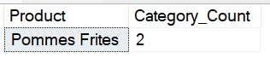

SELECT Product_id, Product, Category
FROM Products
WHERE Product ='Pommes Frites'

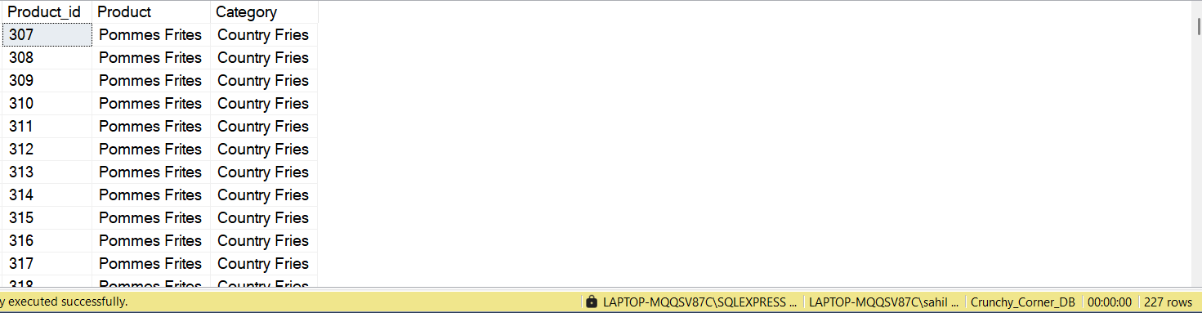

SELECT Product, Category, COUNT(*) Nr_of_Time_Classified
FROM Products
WHERE Product ='Pommes Frites'
Group by Product, Category

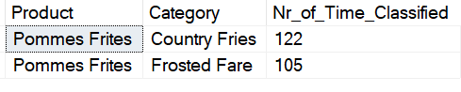

"Pommes Frites" (French fries) should be categorized under Country Fries rather than Frosted Fare, as they are a type of fried potato dish rather than a frozen or dessert item.

UPDATE Products
SET Category = 'Country Fries'
WHERE Category = 'Frosted Fare'
AND product = 'Pommes Frites';

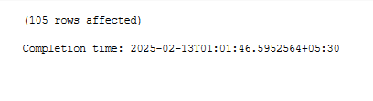

SELECT * FROM Products

-- Recheck
SELECT
Product,
COUNT(DISTINCT Category) as Category_Count
FROM Products
GROUP BY Product
HAVING COUNT(DISTINCT Category)>1

SELECT Product, Category, COUNT(*) Nr_of_Time_Classified
FROM Products
WHERE Product ='Pommes Frites'
Group by Product, Category
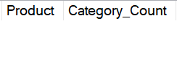

Check for Category/Subcategory Mapping Issues

Each Subcategoryshould belong to only One category:

SELECT Sub_Category, COUNT(DISTINCT Category) AS Category_count
FROM Products
GROUP BY Sub_Category
HAVING COUNT(DISTINCT Category) > 1;

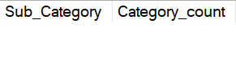

--(4) Format & Standardization Checks
--SKU Code Format Validation

-- Ensure that SKU codes follow a specific format (e.g., alphanumeric, length constraints):
-- Detected Incorrect SKU code in Products table
SELECT *
FROM Products
WHERE
LEN(SKU_code) <> 10 -- Length must be exactly 10
OR
TRY_CAST(SKU_code AS BIGINT) IS NULL; -- Must be a valid number

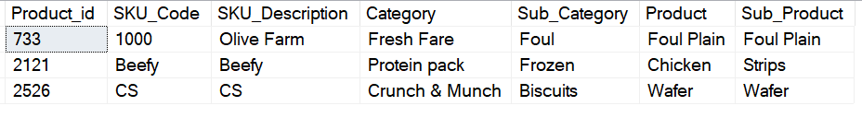
-- Checking whether SKU description is Unique or not
SELECT
SKU_Description,
COUNT(*)
FROM Products
GROUP BY SKU_Description
HAVING COUNT(*) > 1;

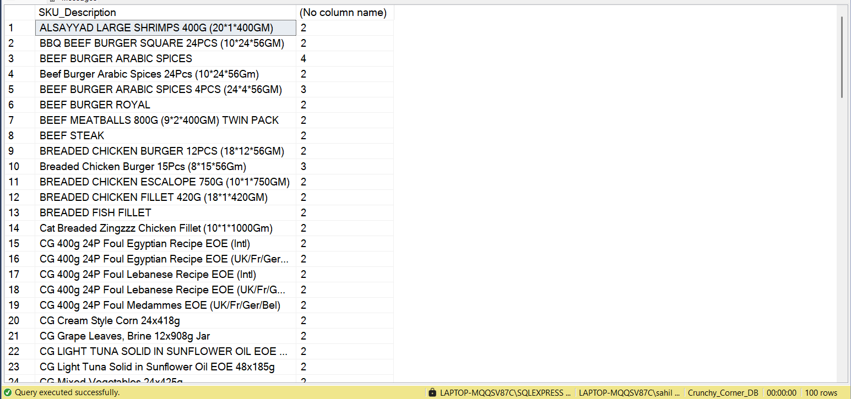

-- (5) Orphan products(Foreign Key check for Fact table)
-- Check if any product_id in the fact table does not exist in the product table:

SELECT f.product_id
FROM Fact_Table f
LEFT JOIN Products p ON f.product_id = p.product_id
WHERE p.product_id IS NULL;

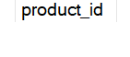

-- (6) Unused or Deprecated Products Check
Identify products that are not used in fact_table (i.e., inactive SKUs):
SELECT p.Product_id, p.SKU_Code, p.Category
FROM Products p
LEFT JOIN Fact_Table f
ON p.product_id = f.product_id
WHERE
f.product_id IS NULL;

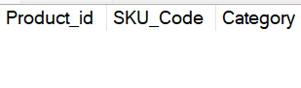

--(7) Outlier Detection for Categories & SKUs
-- Check if any category has an unusually high number of SKUs, which might indicate incorrect mappings:

SELECT Category, COUNT(DISTINCT SKU_Code) AS SKU_count
FROM Products
GROUP BY category
ORDER BY SKU_count DESC;

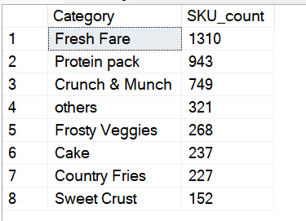

--Check if any Sub_category has an unusually high number of SKUs, which might indicate incorrect mappings:
SELECT Sub_Category category, COUNT(DISTINCT SKU_Code) AS SKU_count
FROM Products
GROUP BY Sub_Category
ORDER BY SKU_count DESC;

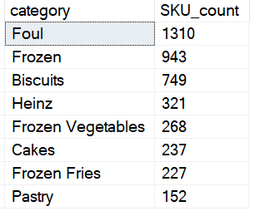

-- (8) Case Sensitivity & Formatting Issues**

--Ensure that Category and Sub_Category names are properly formatted
-- (e.g., title case, no extra spaces):

SELECT Category, Sub_Category
FROM Products
WHERE Category <> UPPER(LEFT(Category, 1)) + LOWER(SUBSTRING(Category, 2, LEN(Category)))
OR Sub_Category <> UPPER(LEFT(Sub_Category, 1)) + LOWER(SUBSTRING(Sub_Category, 2, LEN(Sub_Category)));

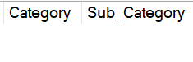

--(9) Standardizing Location Names to State Abbreviations by Data Manipulation

SELECT * FROM Location
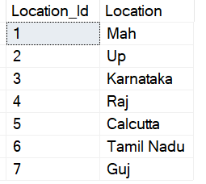

UPDATE Location
SET location =
CASE
WHEN location = 'Mah' THEN 'MH'
WHEN location = 'Up' THEN 'UP'
WHEN location = 'Raj' THEN 'RJ'
WHEN location = 'Guj' THEN 'GJ'
WHEN location = 'Calcutta' THEN 'WB' -- Assuming it's a misspelled "Calcutta"
WHEN location = 'Tamil Nadu' THEN 'TN'
ELSE location -- Keeps other values unchanged
END;
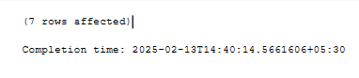

SELECT * FROM Location

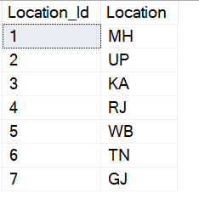
--(10) Date table Data Cleaning and Data Exploration

SELECT * FROM Date_Table
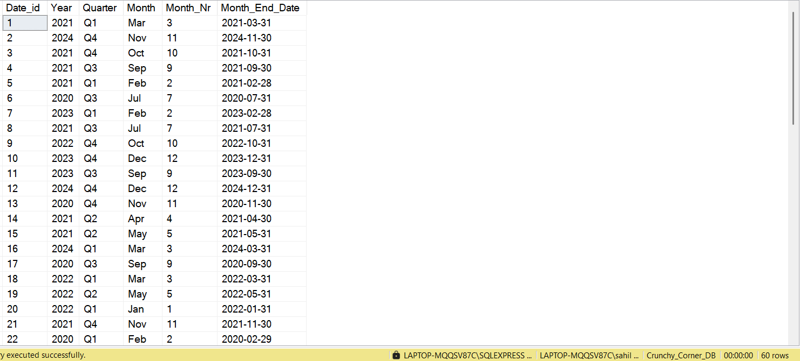

(A)Checking for missing or Null Values

SELECT * FROM Date_Table
WHERE Date_id IS NULL OR Month_End_Date IS NULL

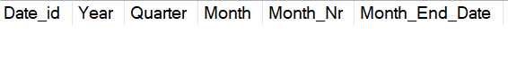

-- (B) Validate Unique date Entries
SELECT Month_End_Date,COUNT(*) FROM Date_Table
GROUP BY Month_End_Date
HAVING COUNT(*) > 1

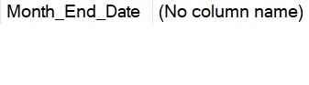
--(C) Checking Date_Id is Unique and Sequential

SELECT Date_id, COUNT(*) FROM
Date_Table
GROUP BY Date_id
HAVING COUNT(*) > 1

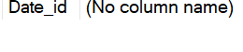

Exploratory Data Analysis of Date_Table

Monthly Distribution of Budget Records: Analyzes transaction counts per month to understand data spread.

Checking Data Completeness: Identifies missing months or unusual variations indicating data anomalies.

Ensuring Correct Aggregation: Validates grouping by Month_End_Date to prevent inconsistencies in reporting.

SELECT
dt.Month_End_Date,
dt.Month_Nr,
dt.Year,
COUNT(*) Nr_of_Transaction
FROM Buget b
JOIN Date_Table dt
ON b.Date_Id = dt.Date_id
GROUP BY
dt.Month_End_Date,
dt.Month_Nr,
dt.Year
Order by
dt.Year,dt.Month_End_Date
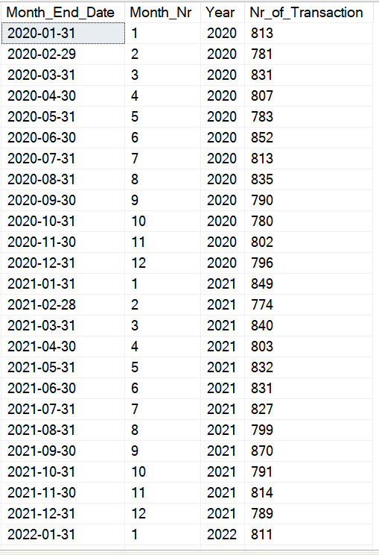

(11) Ensuring Consistent Title Case Formatting in the Channel Table Using SQL

SELECT *
FROM Channel;

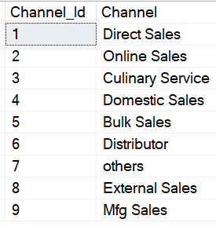

UPDATE Channel
SET Channel = (
SELECT STRING_AGG(
UPPER(LEFT(value, 1)) + LOWER(STUFF(value, 1, 1, '')), ' ')
FROM STRING_SPLIT(Channel, ' ')
);

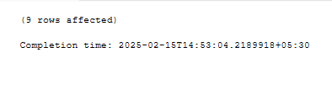

SELECT * FROM Channel;

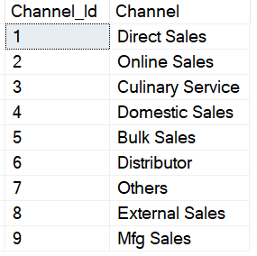

(12) Checking Missing Values(Null) in Fact Table

SELECT
SUM(CASE WHEN Product_id IS NULL THEN 1 ELSE 0 END) AS Missing_Product_id,
SUM(CASE WHEN Cluster_id IS NULL THEN 1 ELSE 0 END) AS Missing_Cluster_id,
SUM(CASE WHEN Channel_Id IS NULL THEN 1 ELSE 0 END) AS Missing_Channel_Id,
SUM(CASE WHEN Location_Id IS NULL THEN 1 ELSE 0 END) AS Missing_Location_Id,
SUM(CASE WHEN Volume_Mt IS NULL THEN 1 ELSE 0 END) AS Missing_Volume_Mt,
SUM(CASE WHEN Gross_Sales IS NULL THEN 1 ELSE 0 END) AS Missing_Gross_Sales,
SUM(CASE WHEN Net_Profit IS NULL THEN 1 ELSE 0 END) AS Missing_Net_Profit
FROM Fact_Table;

